Functionality in respect of Point No. 12 of CASS 2019 Instruction No. 1 dated 24-09-2019
In reference to Point No. 12 of CASS 2019 Instruction No. 1 dated 24-09-2019 issued by Directorate of Income Tax (Systems), Limited Scrutiny cases can be converted into Complete Scrutiny without taking approval of PCIT/CIT in 2 scenarios as defined below:
- Due to case identified for scrutiny in Compulsory Manual Selection in reason 1ia, 1ib, 1ii, and 1iv at later stage
- Due to case identified for scrutiny in Compulsory Manual Selection in reason 1iii (i.e. Search) at later stage
Steps for Conversion of Case in Scenario A are as follows:
- Go to Assessment Module → Worklist → Click on Subject → View the Limited Scrutiny Flag as “Yes”
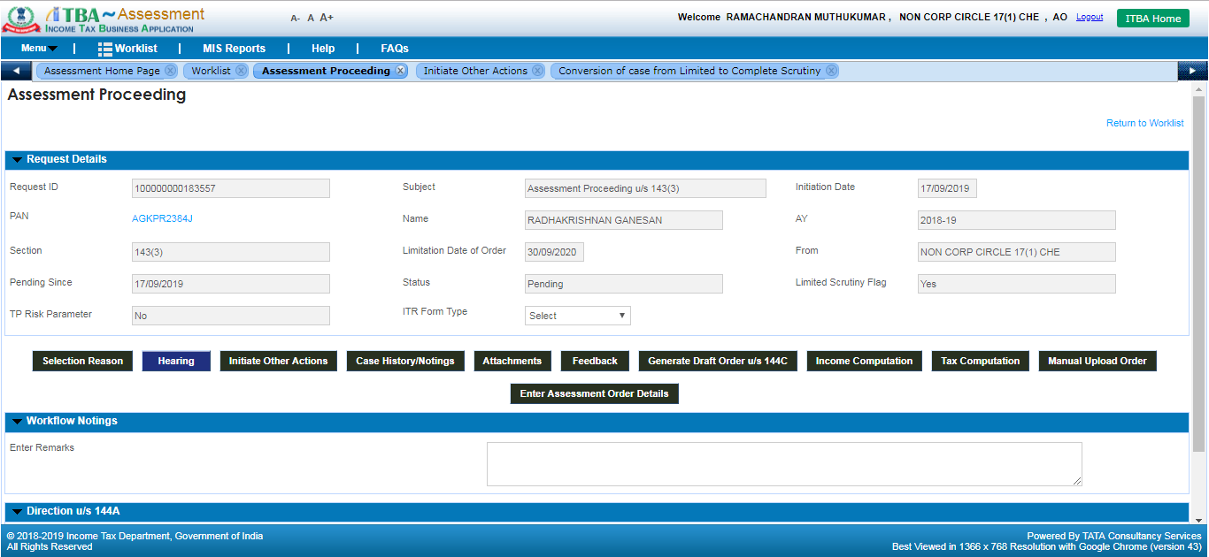
- Click Initiate Other Actions → Click Conversion of Case from Limited to Complete Scrutiny
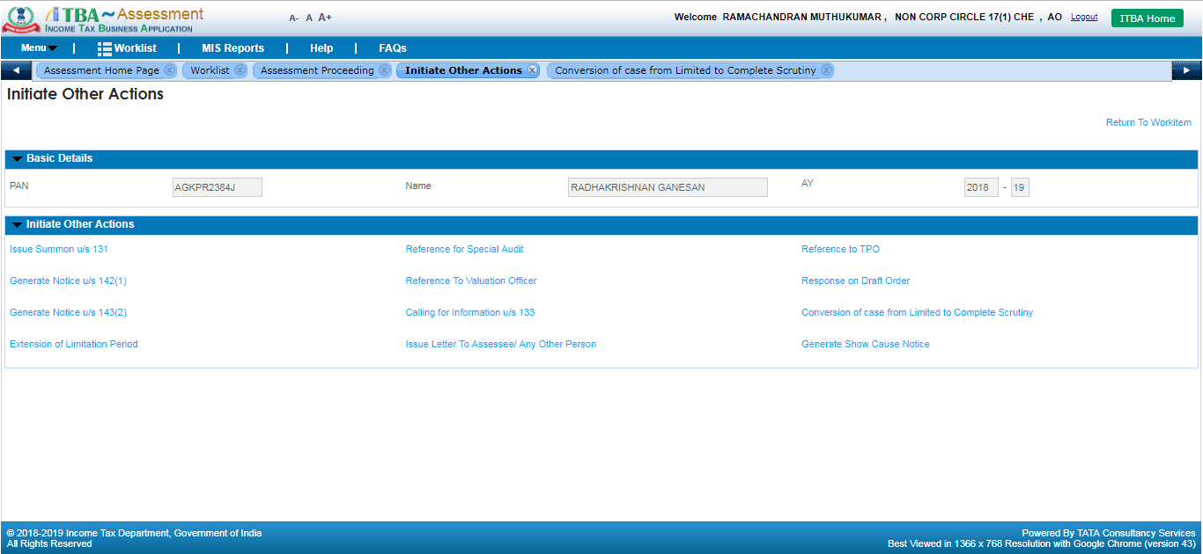
- Select the Check box of “Convert to Complete Scrutiny based on Manual Selection Guidelines“, enter reason and click Submit. User will get below shown informational message to generate the notice u/s 143(2) through manual to system option.
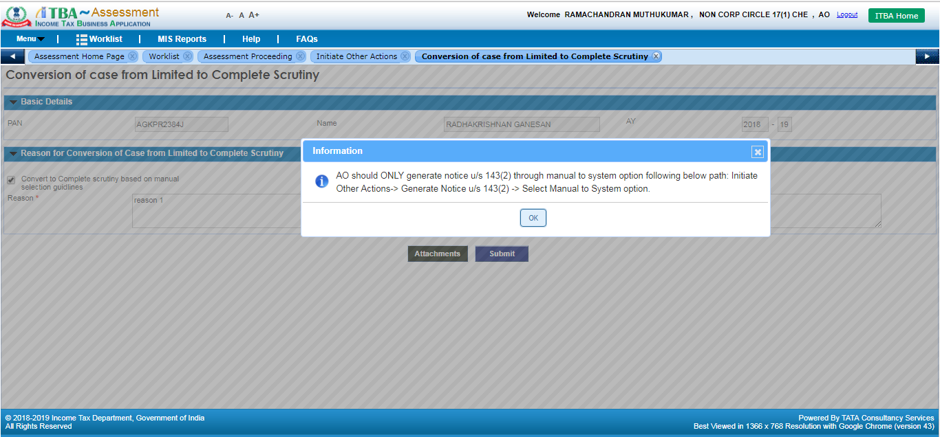
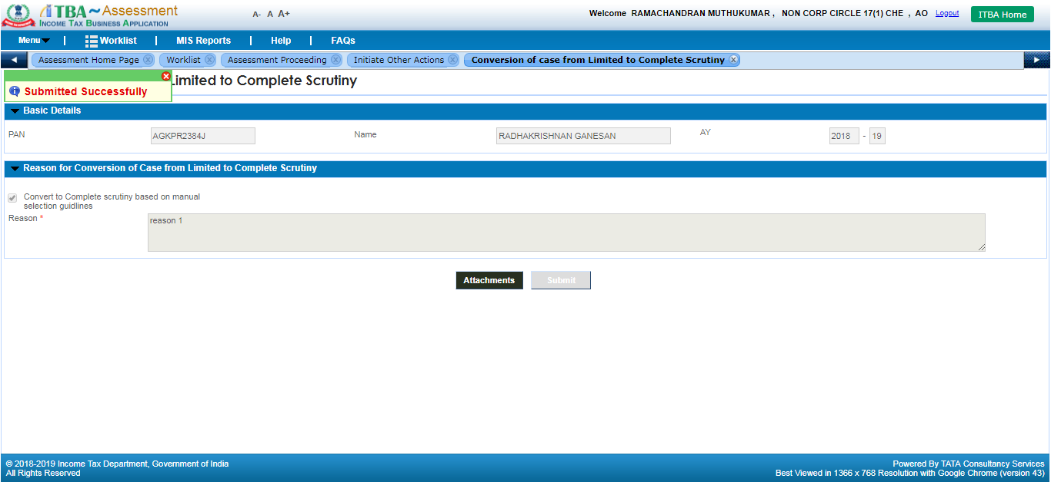
- Case will get converted from Limited to Complete Scrutiny. Limited Scrutiny Flag will be changed to “No” in Assessment Proceedings workitem.
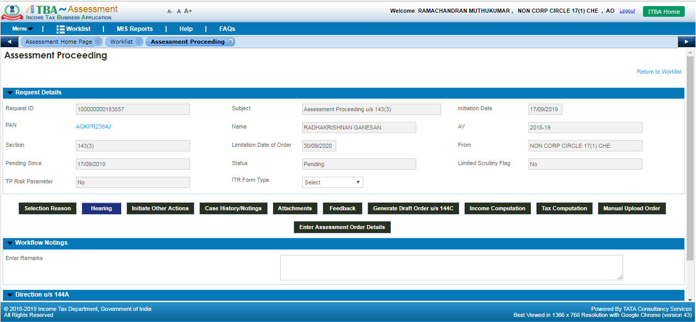

Steps for Conversion of Case in Scenario B are as follows:
- Go to Assessment Module → Worklist → Click on Subject → View the Limited Scrutiny Flag as “Yes”
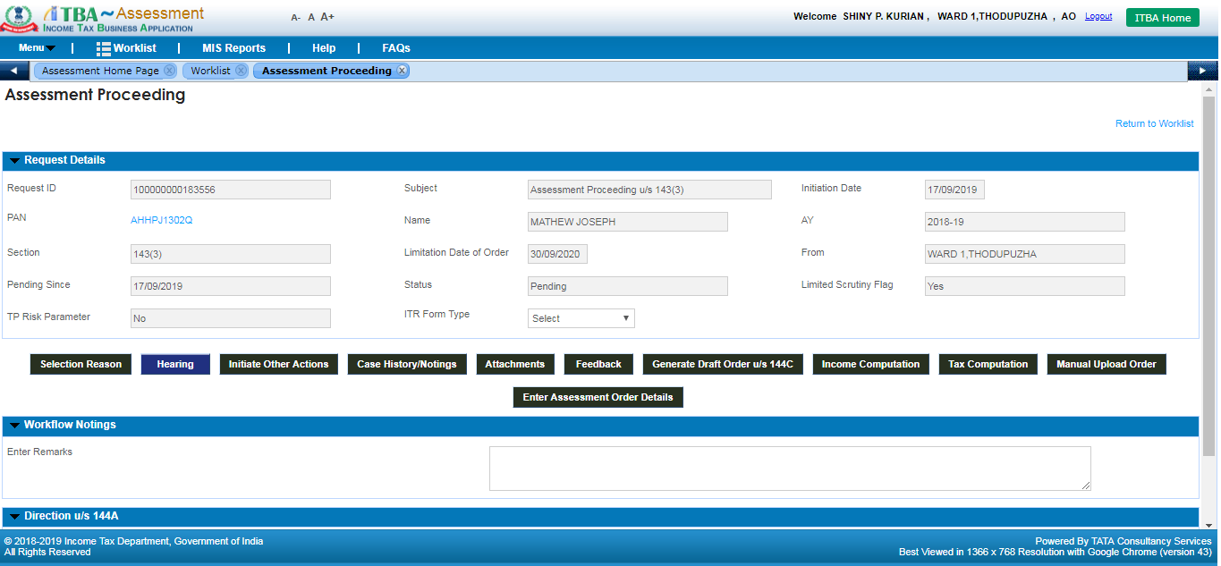
- Go to Assessment Module → Menu → Selection u/s 153A and Relevant Search Year → Add or Search the PAN in screen →Select Notice Year
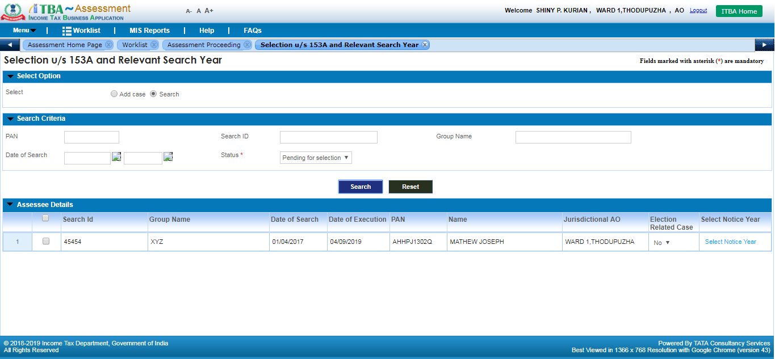

- Select Section as ‘143(2)’ in Search year proceedings, fill other details and click Submit. Below shown confirmation message is displayed. In case, user selects ‘Yes’ then pending proceeding u/s 143(3) of Limited scrutiny gets auto converted into Complete Scrutiny.
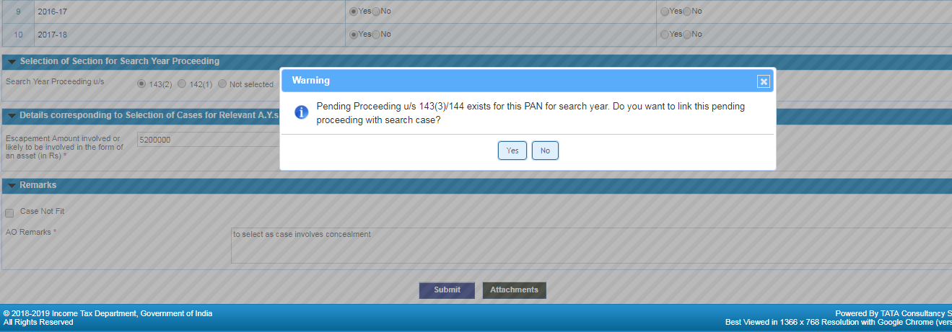
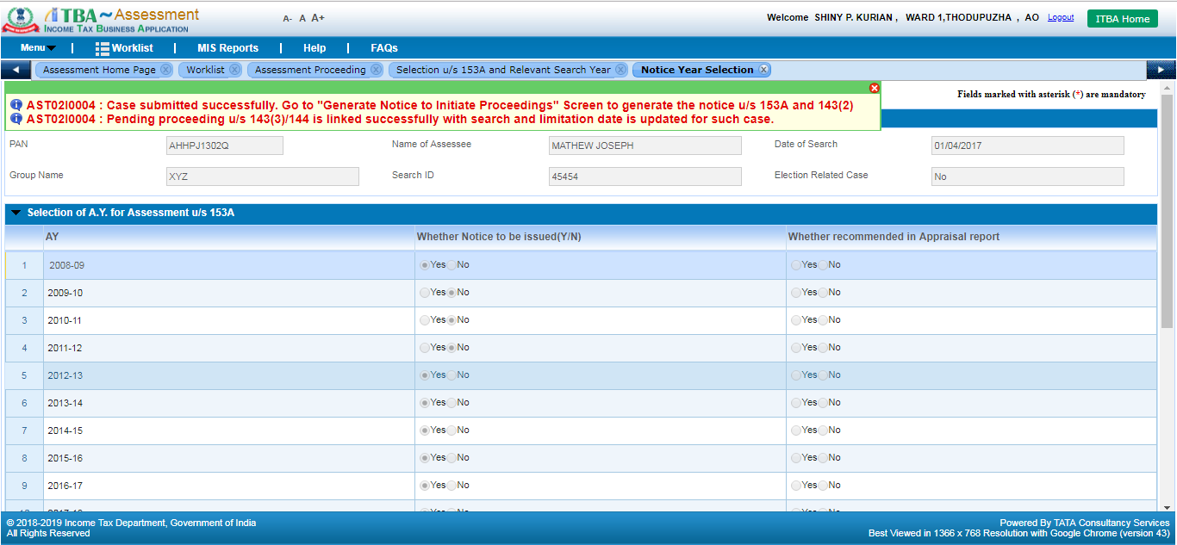
- AO can view the Limited Scrutiny Flag of that proceeding is changes as “No”

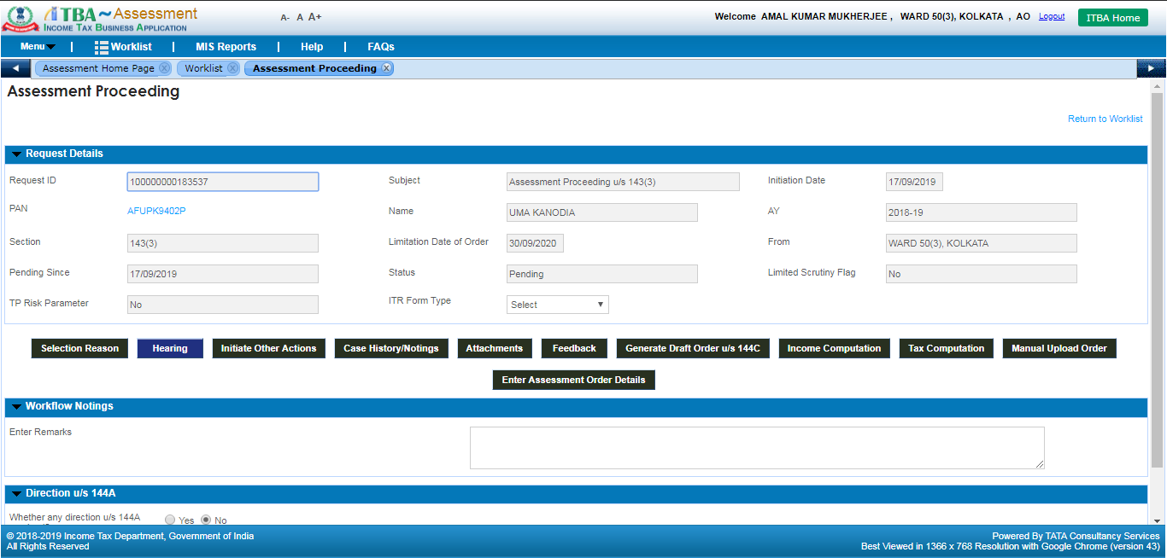
After Conversion of Case, User should generate notice u/s 143(2) through Manual to system following below steps in both A and B scenarios:
- Click Initiate other actions → Generate Notice u/s 143(2) → Select Category, enter description and select the file of notice issued manually outside the system after conversion
- Click Save
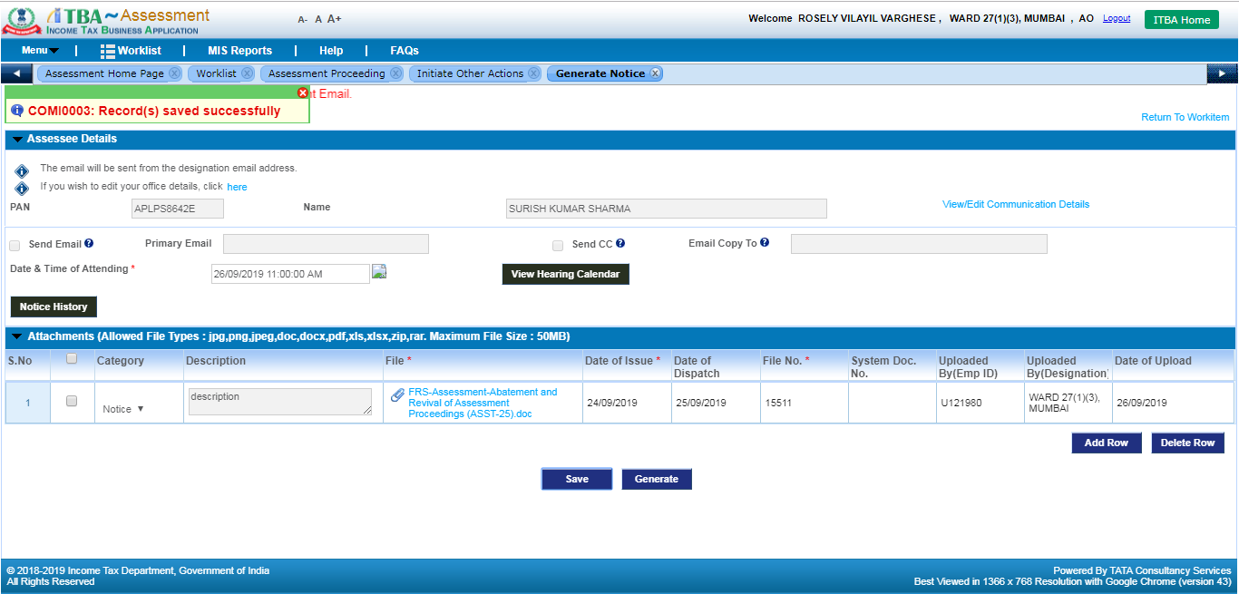
- Click Generate. Manually issued notice will get uploaded in system and shared with E-filing to be made visible to assessee under e-Proceeding Tab. Also, Manual Intimation Letter will get generated against the same having Document Identification Number (DIN) which will be shared with assessee for future reference.
